FEBRUARY 15th 2018
Dear Reynaldo Pacheco,

We, Lata Sagrada SRL herewith state that we control and own all rights to the film “FUERTES”, directed by Oscar Salazar Crespo and Franco Traverso Chueca and based on the script written by Oscar Salazar Crespo and Franco Traverso Chueca (hereinafter referred to as “the film”).
By this mean, we authorize you to represent “the film” for the following purposes:
- Attain funding for postproduction and promotion.
- Negotiate with distributors, one of which being Azteca Television. (Hereinafter referred to as “distributor”). To ensure a concession agreement for “the film”.

In the event a distributor purchases a license to distribute the film in their respective territory or territories, we herewith agree to grant you an executive producer credit for this film and pay you a sales agency fee of 15%(Hereinafter referred to as “agent fee”). Such agent fee would be paid to you within 10 workdays after the licensing payment had been received and deposited on our designated account.

Kindly be advised, that we would have to pre-approve any terms and conditions of any licensing agreement prior to its execution. Our approval shall not be unreasonably withheld.

Thank you very much for your kind assistance in helping us distribute our film via your contacts.

Sincerely,

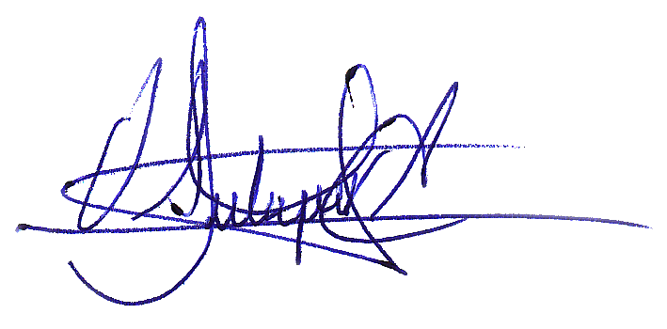
OSCAR SALAZAR CRESPO
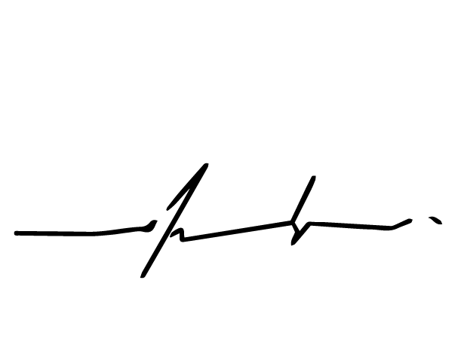
FRANCO TRAVERSO CHUECA

